HR Report: March 13, 2012

New Hire  Diogenes Heer – Utility, South Haven Campus  Diog began work at the South Haven campus on February 27, 2012. As a part-time Utility department member, he provides general building and grounds maintenance and assists with electrical, plumbing and carpentry work. Diog is a graduate of Coloma High School and worked as a Customer Specialist and Maintenance Coordinator at Sunset Lodge and Ruth’s Laundry since 1997. | 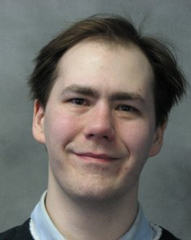

New Hire  Kathleen Logsdon-Assessment & Learning Assistance Coordinator, South Haven  Lake Michigan College welcomed Kathy on March 7, 2012 as part-time Assessment & Learning Assistance Coordinator. Kathy works as a team member in the Assessment and Learning Assistance Center, supervising assessment proctors and tutors. A graduate of Siena Heights University with a Bachelor of Arts, she has a diverse professional history of community college and adult education work experience. Kathy worked as an LMC Adjunct Instructor for three years, teaching Freshman Seminar and Reading Improvement and Strategies classes. | 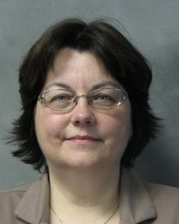

Departure  Charles Shasky, Career Developer, Michigan Works! Benton Harbor, resigned February 24, 2012 | 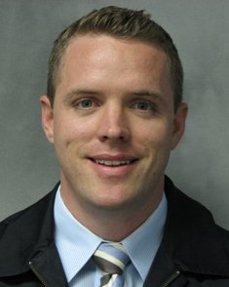

Departure  Bryan Russell, part-time Utility, South Haven, resigned February 27, 2012 | 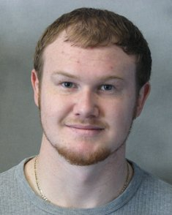

Departure  Paget Mangold, part-time Academic Advisor, South Haven resigned March 5, 2012 | 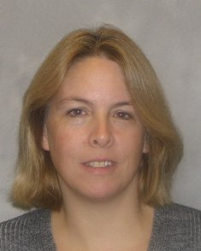

Departure  Juli Enders, Career Developer, Michigan Works! Benton Harbor, resigned March 9, 2012 | 