New Hires:
Christine Coble – Event Manager – 9/4/2012  As the Event Manager, Christine will work as the liaison between external clients and on-site staff, developing relationships with customers and coordinating their special events hosted at the Mendel Center. A graduate of Southwestern Michigan College with an Associate degree in Liberal Arts, Christine most recently worked as the Events Assistant Manager at Shadowland Ballroom. | 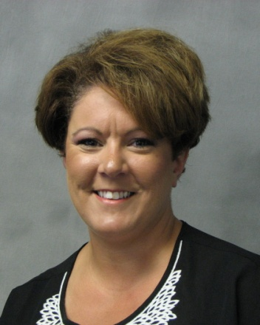
Karen Broadwater – Program Operations Manager, Employment Services - 9/4/2012  Karen returned to the Michigan Works! team as the Program Operations Manager, Employment Services. In this role, she will direct and coordinate Wagner-Peyser daily activities at the Berrien, Cass, and Van Buren county Michigan Works! service centers. Karen received a Master of Arts in Organizational Leadership from Siena Heights University and has worked as a Secretary at M-TEC and Career Developer at Michigan Works! in Benton Harbor. | 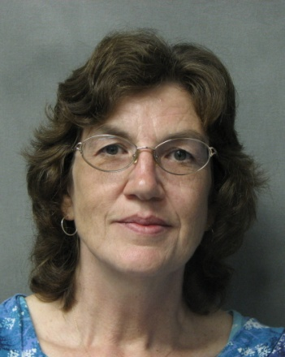
Michael Breyen - WFF Custodial Manager  Michael joins WFF with 20 years of experience in the hospitality industry, bringing his strengths in team management, staff development and customer service. | 